**DAILY REPORT**

**Student Name :SINDHU.N**

**Class and Sec : VI B**

**USN :4AL17CS094**

**DATE:11-07-2020**

|  |  |  |  |  |
| --- | --- | --- | --- | --- |
| **Online Test Details** | | | | |
| **Subject** | **---** | | | |
| **Semester** | **VI -B** | | **Duration** | **------** |
| **% of marks** | | **----** | | |

|  |  |  |  |
| --- | --- | --- | --- |
| **Certification Course Details** | | | |
| **Course** | Python Data Structure | | |
| **Certificate Provider** | coursera | **Duration** | 19hours |

**Snapshots of the daily class acitivities .**

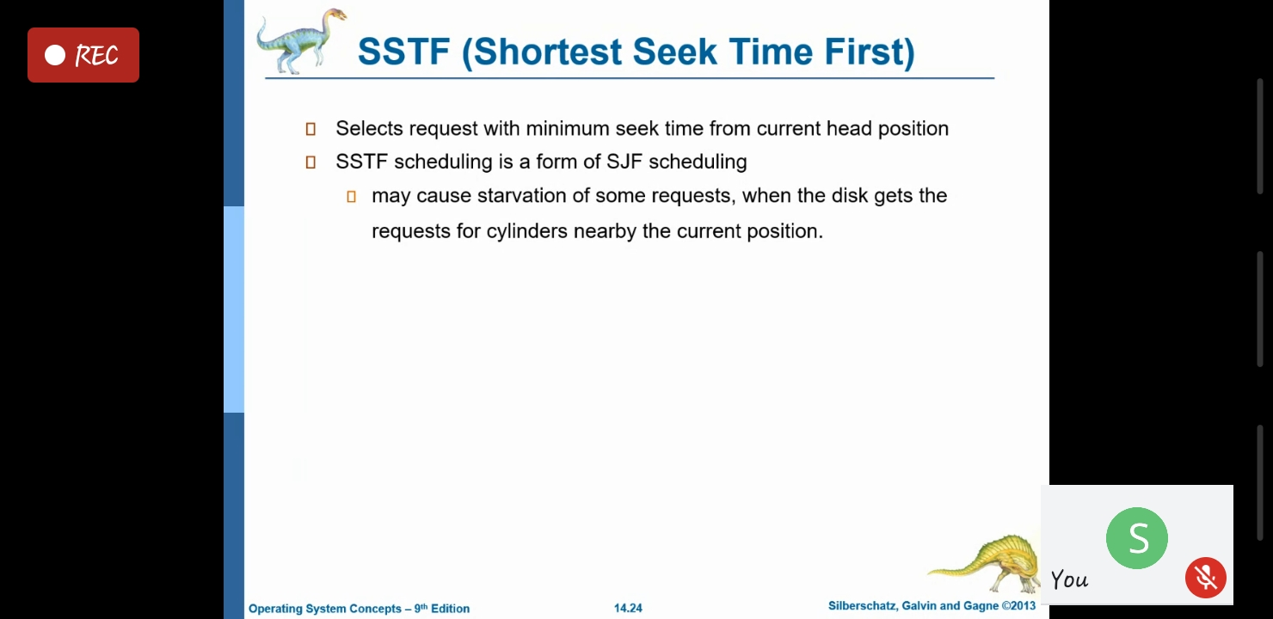

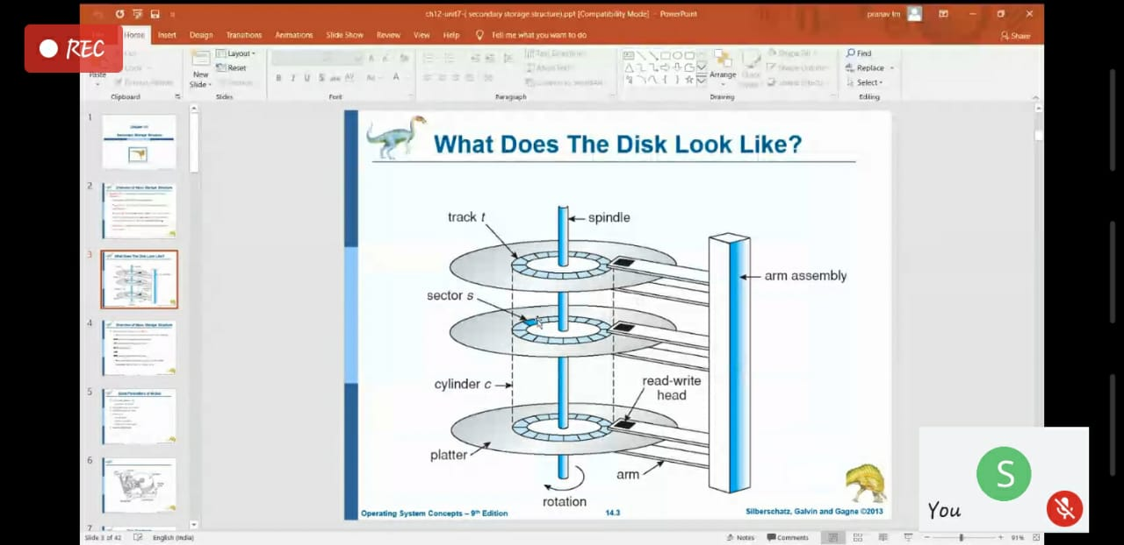

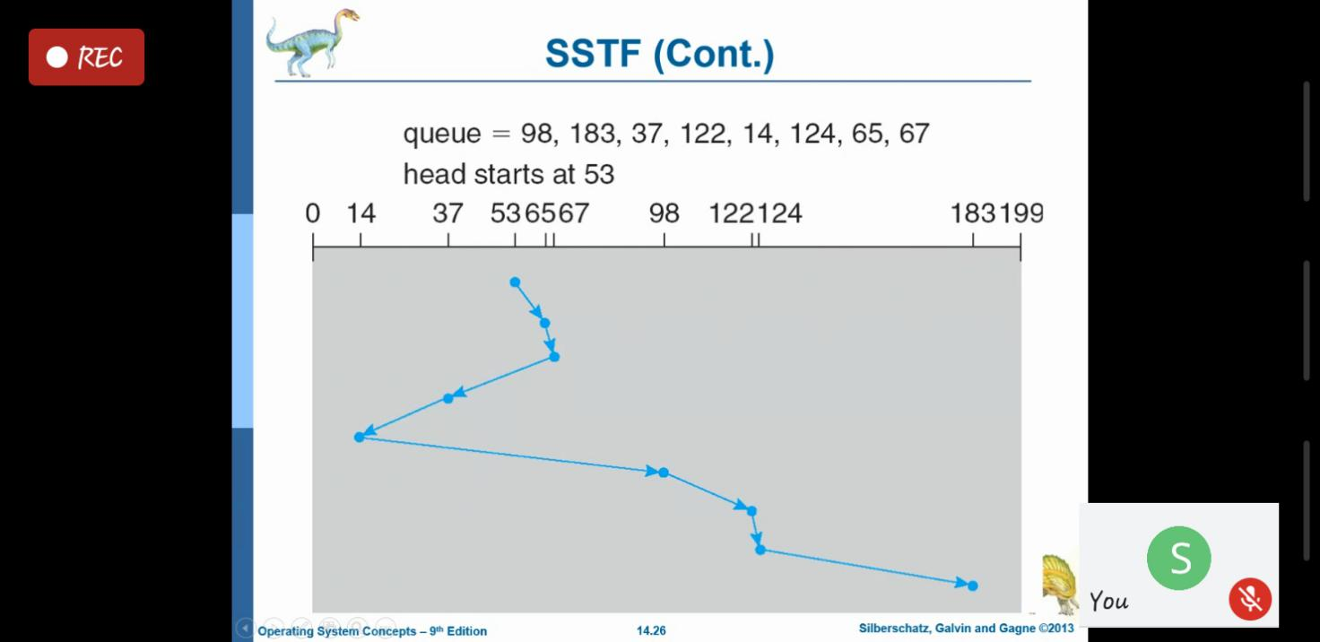

|  |  |
| --- | --- |
| **Coding Challenges** | |
| **Problem Statement: 1.Python Program for Product of unique prime factors of a number.** | |
| **Status:** Executed | |
| **Uploaded the report both in Github & Slack** | Yes |

**Snapshots of your response to challenge.**

1. ****Python Program for Product of unique prime factors of a number.****

**n=int(input("Enter an integer:"))**

**print("Factors are:")**

**i=1**

**while(i<=n):**

**k=0**

**if(n%i==0):**

**j=1**

**while(j<=i):**

**if(i%j==0):**

**k=k+1**

**j=j+1**

**if(k==2):**

**print(i)**

**i=i+1**

****OUTPUT****

